Riphah International University
Gulberg Green Campus Islamabad
Faculty of Computing
Semester: SE4 - Software Requirement Engineering
Submitted To: Ma’am Amber Khalil
Submitted By:
Name | SAP ID
Aima Eman Aziz | 65113
Manahil Tahir | 63548
Syeda Masooma Zahra | 63410
Khansa Kaleem | 62607

Table of Contents
Smart Study Planner System 4
Part:01 5
Introduction 5
Importance of Clear and Complete Requirements 5
Types of Requirements in the Smart Study Planner System 5
Part:02 6
Core Problems Faced by Students 6
Causes of These Problems 7
Proposed Solution by the System 7
Progress Tracking 8
Business Value of the System 8
Part:03 8
Introduction 8
List of Stakeholders 9
Stakeholders and Their Roles 9
Stakeholder Interaction with the System 10
Part:04 10
Introduction 10
Functional Requirements 10
Non-Functional Requirements 11
2. Performance 11
System Scope 12
Part:05 12
Introduction 12
Interview with Students 12
Brainstorming Session 13
Miro Diagram Explanation 13
Part:06 15
Storyboard for Smart Study Planner System 15
Introduction 15
User Interaction Flow 16
Frame 1 – Opening the App 16
Frame 2 – Adding Study Tasks 16
Frame 3 – Viewing & Managing Tasks 16
Frame 4 – Smart Scheduling & Reminders 17
Frame 5 – Progress Tracking 17
Frame 6 – Calendar & Deadline Overview 17
Step-by-Step User Journey 18
Part:07 19
Introduction 20
1. Actors of the System 20
Primary Actors 20
Part: 08 22
Introduction 23
Actors Involved (Swimlanes) 23
Activity Flow 23
24
Key Elements of the Diagram 24

Table of Figures
Figure 1 14
Figure 2 15
Figure 3 19
Figure 4 20
Figure 5 24

Smart Study Planner System
In recent years, educational institutions have observed that students struggle to effectively manage their academic workload due to increasing course demands, multiple deadlines, and lack of structured planning tools. Many students rely on manual methods such as notebooks or basic mobile reminders, which often lead to missed deadlines, poor time allocation, and increased academic stress.
A survey conducted within a college revealed that:
• Students often fail to prioritize tasks properly
• Deadlines from multiple subjects overlap, causing confusion
• There is no centralized system to track assignments, exams, and study goals
• Existing tools are either too complex or not tailored to student needs

To address these challenges, a Smart Study Planner System is proposed. This system will act as an intelligent assistant that helps students organize their study schedules based on workload, deadlines, and priorities. It will allow users to input tasks, set deadlines, receive automated reminders, and monitor their progress over time.
The system is expected to provide a simple, user-friendly interface that supports efficient planning while ensuring flexibility for different study patterns. Additionally, it should support features such as task categorization, priority setting, and progress tracking.
From a development perspective, the system involves multiple stakeholders, including students (primary users), teachers (who define deadlines and workload), and system administrators (who manage system operations). Each stakeholder has different expectations and requirements that must be carefully analyzed and documented.
As a Software Requirements Engineer, your role is to:
• Analyze the business problem and identify its root causes
• Gather and document system requirements through appropriate elicitation techniques such as interviews and brainstorming
• Identify stakeholders and define their roles
• Clearly define the system scope and constraints
• Model the system using UML diagrams such as Use Case and Activity Diagrams
• Design a storyboard to visualize user interaction with the system

The success of this system depends on how well the requirements are understood, structured, and documented. Poorly defined requirements may lead to system failure, while clear and precise requirements will ensure that the system effectively solves the identified problem.

Part: 01

Analyze the given scenario and explain how software requirements play a role in developing the Smart Study Planner System.
• Identify the importance of clear and complete requirements
• Differentiate between types of requirements in the system

Role of Software Requirements in Smart Study Planner System

Introduction
- Software Requirements Engineering (SRE) helps in identifying and documenting user needs before system development.
- It is important because students face issues like poor time management and overlapping deadlines.
- Clear requirements ensure the system solves real academic problems effectively.
Role of Software Requirements in Developing the System
- Requirements help in understanding student problems like task management and prioritization issues.
- They define system features such as task creation, reminders, and progress tracking.
- They ensure clear communication between students, teachers, and developers.
- Requirements guide developers in building the system correctly.
- They reduce risks by avoiding missing or incorrect features.

Importance of Clear and Complete Requirements
- Clear requirements reduce confusion among stakeholders.
- Complete requirements ensure no important feature is missed.
- They save time and cost by reducing rework.
- They improve system quality and reliability.
- They make testing and validation easier.

Types of Requirements in the Smart Study Planner System
Functional Requirements
- Functional requirements define what the system should do.
- They include adding tasks, setting deadlines, and sending reminders.
- They also allow users to track study progress.

Non-Functional Requirements
- Non-functional requirements define how the system should perform.
- The system should be user-friendly and easy to use.
- It should be fast, reliable, and secure.

User Requirements
- User requirements describe system needs in simple language.
- They focus on what students expect from the system.
- Example: The system should help manage study schedules easily.
System Requirements
- System requirements are detailed and technical descriptions.
- They guide developers during implementation.
- Example: The system should send reminders before deadlines.

Part: 02
Perform a detailed business and problem analysis of the system.
• Identify the core problems faced by students
• Analyze the causes of these problems
• Propose how the system will solve these issues

Business and Problem Analysis

Core Problems Faced by Students
Students in educational institutions face several major issues in managing their academic workload:
- Poor Task Prioritization
Students are unable to decide which task is more important, leading to inefficient study planning.
- Overlapping Deadlines
Assignments, quizzes, and exams from multiple subjects often clash, creating confusion and stress.
- Lack of Centralized System
Students use scattered tools (notebooks, mobile reminders), resulting in disorganized tracking of tasks.
- Ineffective Time Management
Without proper scheduling, students either overwork or underutilize their available time.
- Missed Deadlines
Due to lack of reminders or poor planning, important academic deadlines are often missed.
- Increased Academic Stress
Poor planning leads to last-minute work, causing anxiety and reduced performance.

Causes of These Problems
The root causes behind these issues include:
- Manual Planning Methods
Traditional methods like notebooks are not dynamic and cannot adjust based on workload changes.
- Lack of Intelligent Tools
Existing tools do not provide smart suggestions based on priorities and deadlines.
- Fragmented Information
Academic tasks are not stored in one place, making it difficult to track everything efficiently.
- No Automated Reminders
Students rely on memory or basic alerts, which are often ignored or insufficient.
- Limited Customization
Available applications are either too complex or not tailored to students’ academic needs.
- Poor Awareness of Time Allocation
Students do not have insights into how much time each task requires.

Proposed Solution by the System
The Smart Study Planner System will address these problems through the following solutions:
Task Management System
- Allows students to add, edit, and delete tasks
- Enables categorization (assignments, exams, study sessions)

Priority-Based Scheduling
- Students can set priority levels (high, medium, low)
- System can suggest task order based on urgency and importance

Centralized Dashboard
- All academic activities are available in one unified platform
- Provides a clear overview of upcoming deadlines

Automated Reminders
- Sends notifications for deadlines and study sessions
- Helps students stay on track

Smart Time Allocation
- Suggests study schedules based on workload
- Helps distribute tasks evenly over time

Progress Tracking
- Students can monitor completed and pending tasks
- Encourages consistency and productivity

User-Friendly Interface
- Simple and easy-to-use design
- Tailored specifically for students’ needs

Business Value of the System
The system provides value to stakeholders in the following ways:
- For Students:
Improves academic performance, reduces stress, and enhances time management
- For Teachers:
Ensures students follow deadlines and stay organized
- For Institutions:
Leads to better overall academic outcomes and student satisfaction

Part: 03
Identify all stakeholders involved in the system.
• List different stakeholders
• Define their roles in system development
• Explain how each stakeholder interacts with the system

Stakeholder Identification and Analysis

Introduction

Stakeholders are individuals or groups who are directly or indirectly involved in the system or are affected by it. Identifying stakeholders is essential to ensure that all requirements are properly gathered and the system meets user expectations.

List of Stakeholders
The Smart Study Planner System includes the following stakeholders:
- Students (Primary Users)
- Teachers / Instructors
- System Administrators
- Developers (Development Team)
- Educational Institution

Stakeholders and Their Roles

1. Students (Primary Users)
Students are the main users of the system.
Roles:
- Add and manage study tasks (assignments, exams, goals)
- Set priorities and deadlines
- View schedules and reminders
- Track their academic progress

2. Teachers / Instructors
Teachers provide academic-related information.
Roles:
- Assign tasks, quizzes, and exams
- Set deadlines for coursework
- Provide workload details to students
- Monitor student progress (if system allows)

3. System Administrators
Administrators manage the system operations.
Roles:
- Maintain and manage the system
- Handle user accounts and access control
- Ensure system security and performance
- Update and manage system features

4. Developers (Development Team)
Developers are responsible for building the system.
Roles:
- Design and develop system features
- Implement requirements into software
- Fix bugs and improve system performance
- Maintain and update the system

5. Educational Institution
The institution is the organization where the system is implemented.
Roles:
- Provide infrastructure and support
- Ensure system adoption among students and teachers
- Monitor overall system effectiveness
- Define policies related to system usage

Stakeholder Interaction with the System
- Students interact directly with the system by entering tasks, viewing schedules, and receiving reminders.
- Teachers interact by providing deadlines and academic requirements.
- Administrators interact by managing system operations and users.
- Developers interact during development and maintenance phases.
- Institution interacts at a higher level by monitoring and supporting the system.

Part: 04
Based on the scenario, extract system requirements.
• Identify basic functional requirements
• Identify non-functional requirements
• Clearly define the scope of the system.

System Requirements Specification

Introduction
System requirements define what the Smart Study Planner System should do and how it should perform. These requirements are divided into functional requirements, non-functional requirements, and system scope to ensure clarity and completeness.

Functional Requirements

Functional requirements describe the core features and operations of the system.

1. User Management
- The system shall allow users (students) to register and log in
- The system shall allow users to update their profile information

2. Task Management
- The system shall allow users to add new tasks (assignments, exams, study goals)
- The system shall allow users to edit and delete tasks
- The system shall allow users to categorize tasks (e.g., assignment, quiz, exam)

3. Priority and Scheduling
- The system shall allow users to set priority levels (high, medium, low)
- The system shall organize tasks based on deadlines and priorities
- The system shall generate a study schedule for users

4. Reminder and Notification System
- The system shall send reminders for upcoming deadlines
- The system shall notify users about pending tasks

5. Progress Tracking
- The system shall allow users to mark tasks as completed
- The system shall display progress (completed vs pending tasks)

6. Dashboard
- The system shall provide a centralized dashboard
- The dashboard shall display all tasks, deadlines, and schedules

Non-Functional Requirements
Non-functional requirements describe how the system performs and its quality attributes.
1. Usability
- The system should be user-friendly and easy to navigate
- The interface should be simple and understandable for students

2. Performance
- The system should respond quickly to user actions
- The system should handle multiple users efficiently

3. Reliability
- The system should operate without crashes or errors
- Data should be saved securely without loss

4. Security
- The system should ensure secure login and authentication
- User data should be protected from unauthorized access

5. Scalability
- The system should support an increasing number of users
- It should handle large amounts of tasks and data

6. Availability
- The system should be available to users at all times (24/7 access)

System Scope

The scope defines what is included and excluded in the system.

In-Scope
- Task creation, editing, and deletion
- Priority setting and scheduling
- Reminder and notification system
- Progress tracking
- User account management
- Dashboard for task overview

Out-of-Scope
- Integration with external academic systems (e.g., LMS)
- Advanced AI-based predictions (future enhancement)
- Teacher grading systems
- Financial or payment-related features

Part: 05
Perform collaborative requirement gathering activities.
• Conduct an Interview with potential users (students)
• Perform a Brainstorming session to generate system features
• Document findings using Miro (or any similar tool)

Collaborative Requirement Gathering

Introduction
Requirement gathering is an essential phase in software development. For the Smart Study Planner System, collaborative techniques such as interviews and brainstorming were used to collect user requirements. The collected information was then organized visually using Miro to improve clarity and understanding.

Interview with Students
Purpose
To understand real problems faced by students in managing their academic workload.
Findings
- Students rely on manual planning methods
- They face difficulty in prioritizing tasks
- Deadlines often overlap
- Many students miss deadlines
- Students experience academic stress

Brainstorming Session
Purpose
To generate ideas and features for solving student problems.

Generated Ideas
- Task management system
- Priority-based scheduling
- Automated reminders
- Progress tracking
- Calendar view
- User-friendly interface

Selected Features
- Task creation & management
- Deadline reminders
- Smart scheduling
- Progress monitoring
- Dashboard view

Miro Diagram Explanation

The diagram created using Miro visually represents the requirement gathering process. It is divided into four main sections:

1. Student Problems
- Missed Deadlines
- Poor Task Prioritization
- Overlapping Assignments
- High Academic Stress

2. Causes of Issues
- Manual Planning
- No Reminders
- Scattered Information
- Lack of Prioritization

3. Proposed Features
- Task Management
- Priority Scheduling
- Automated Reminders
- Progress Tracking
- Calendar View
- User-Friendly Interface

4. Solution Mapping
This section connects problems with solutions:
- Missed Deadlines → Deadline Alerts
- Poor Planning → Smart Scheduling
- Scattered Tasks → Centralized Dashboard
- Stress → Organized Task Management

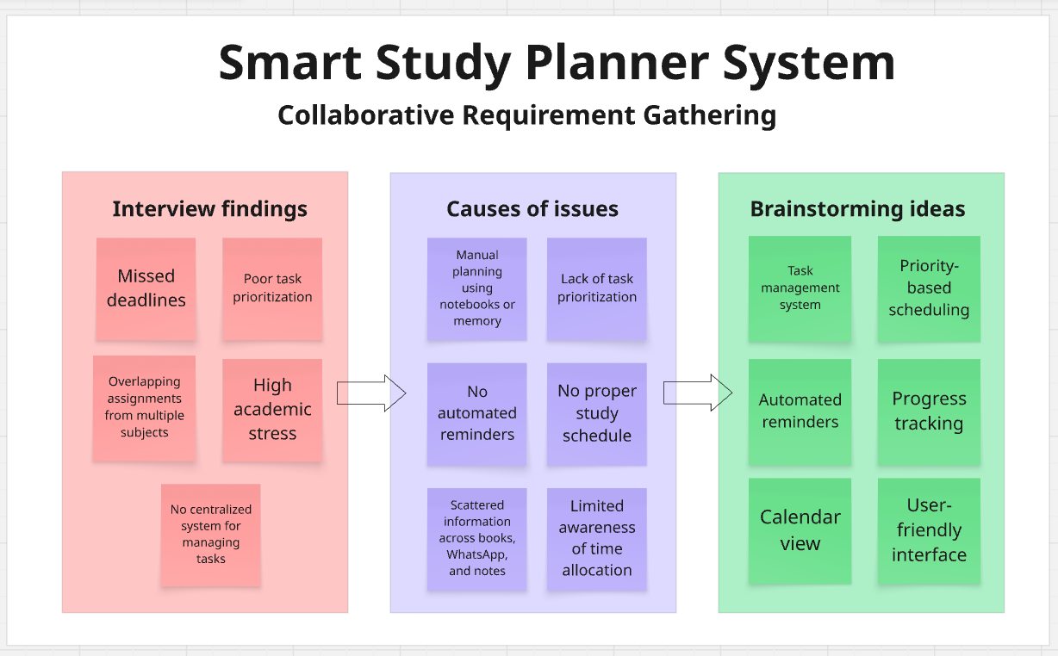
Figure 1

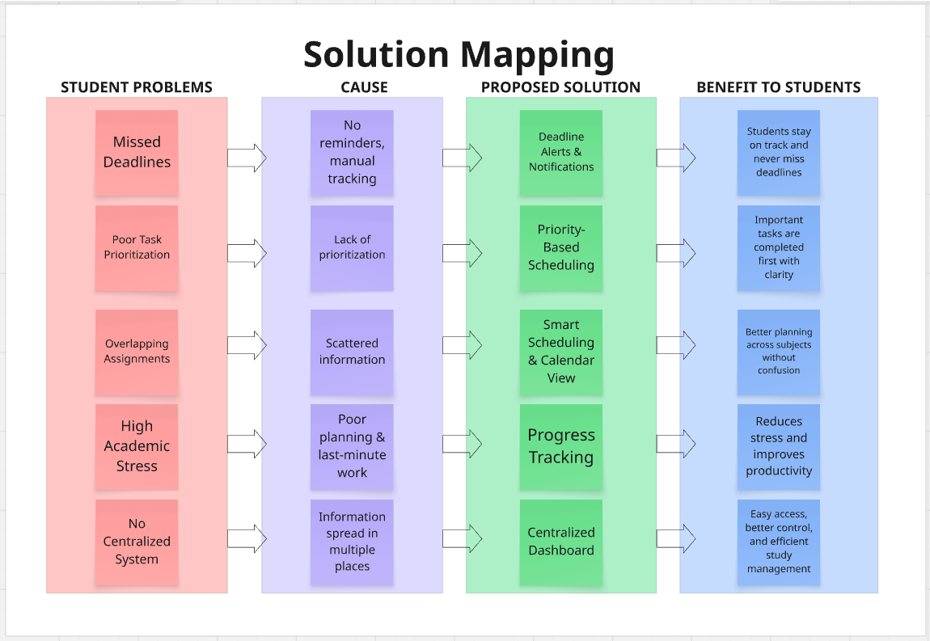
Figure 2

Part: 06
Create a storyboard for the Smart Study Planner System.
• Design user interaction flow
• Show step-by-step user journey
• Use Figma (or similar tool) to visualize screens

Storyboard for Smart Study Planner System

Introduction

The storyboard visually explains how a student interacts with the Smart Study Planner System from opening the app to managing tasks, tracking progress, and viewing deadlines. It shows the complete user journey step by step and demonstrates how the system helps students stay organized and productive.

User Interaction Flow

Frame 1 – Opening the App
Description:
The student opens the Smart Study Planner application. The home screen dashboard appears with an overview of today's schedule, upcoming deadlines, and pending tasks.

Features:
- Dashboard overview
- Today's schedule
- Upcoming deadlines
- Pending tasks summary
- Navigation bar

Outcome:
The user can quickly access tasks, calendar, and progress tracking.

Frame 2 – Adding Study Tasks
Description:
The student clicks on the Add Task button to create a new task. A form opens where the user enters task details.

Features:
- Subject name
- Task description
- Deadline date
- Priority level (High, Medium, Low)
- Save task button

Outcome:
The task is saved successfully into the system.

Frame 3 – Viewing & Managing Tasks
Description:
The student views all tasks in an organized list categorized by subject or priority. Tasks are color-coded according to urgency.

Features:
- Task list
- Priority colors
- Edit task option
- Delete task option
- Mark as completed

Outcome:
The student can easily manage tasks and avoid confusion.

Frame 4 – Smart Scheduling & Reminders
Description:
The system automatically generates a study schedule based on deadlines and workload. Notifications and reminders are sent for upcoming tasks and exams.

Features:
- Auto-generated schedule
- Smart time allocation
- Reminder notifications
- Exam alerts
- Deadline warnings

Outcome:
The student stays on track and avoids missed deadlines.

Frame 5 – Progress Tracking
Description:
The student opens the progress dashboard to monitor performance. It shows completed tasks, pending work, and study statistics.

Features:
- Completed tasks report
- Pending tasks report
- Productivity charts
- Progress bars
- Weekly performance summary

Outcome:
The student evaluates productivity and improves study habits.

Frame 6 – Calendar & Deadline Overview
Description:
The student accesses the calendar interface where assignments, quizzes, and exams are displayed on dates.

Features:
- Monthly calendar
- Deadlines display
- Event highlights
- Overlapping task alerts
- Subject scheduling view

Outcome:
The student can plan workload efficiently and manage time better.

Step-by-Step User Journey
- Student opens the app and views dashboard
- Student adds study tasks with deadlines and priority
- Student manages task list regularly
- System creates schedule and sends reminders
- Student tracks progress through dashboard
- Student checks calendar for upcoming deadlines
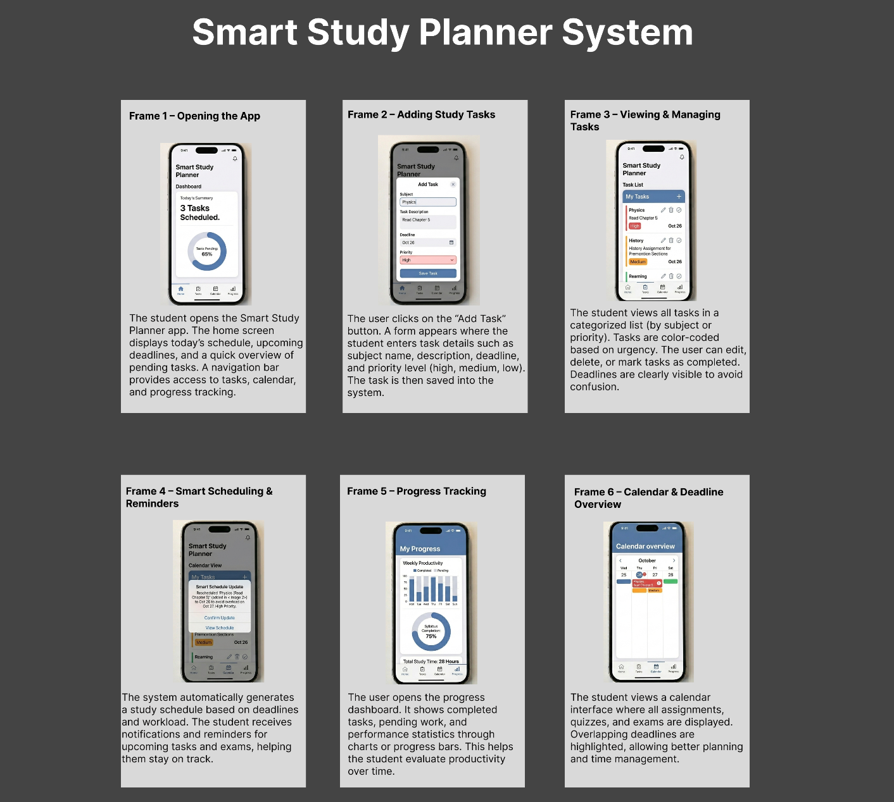
Figure 3

Part: 07
Develop use case modelling for the system.
• Draw a Use Case Diagram
• Create at least one Fully Dressed Use Case
• Highlight all elements (actors, preconditions, postconditions, etc.)

Use Case Modeling for Smart Study Planner System

Introduction
Use Case Modeling is used to represent the functional requirements of a system. It shows how different users (actors) interact with the system to perform specific tasks. For the Smart Study Planner System, the use case model helps in understanding system operations and user responsibilities.

1. Actors of the System

Primary Actors
Student
The main user of the system who manages study tasks, schedules, and progress.

Teacher
Provides assignments, deadlines, exams, and workload details.

Administrator
Manages users, system settings, and overall maintenance.

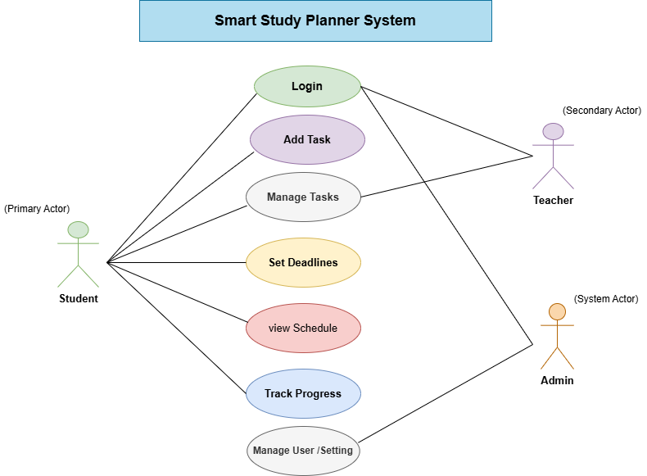
Figure 4
2. Fully Dresses Use Case
- Section | Content
- Designation | UC-1
- Name | Smart Study Planning & Management System
- Authors | Manahil Tahir, Aima Eman Aziz, Syeda Masooma Zahra
- Priority | High
- Criticality | Critical
- Source | Student & Teacher Requirements
- Responsible | Development Team
- Description | This use case allows students to manage academic workload by adding tasks, setting priorities, generating study schedules, receiving reminders, and tracking progress efficiently.
- Trigger Event | Student logs in and opens dashboard
- Actors | Primary Actor: Student  Supporting Actors: System (Scheduler, Reminder), Database  Offstage Actors: Teacher, Admin
- Preconditions | Student must be registered and logged in  System must be active  Tasks/subjects available or can be entered  Teacher deadlines (if any) are defined
- Postconditions | Tasks are saved/updated/deleted  Study schedule is generated  Reminders are set  Progress is stored
- Result | Student successfully manages study plan and meets deadlines
- Main Scenario | 1. Student logs into system  2. System displays dashboard  3. Student adds task  4. Student enters details  5. System saves task  6. System generates study schedule  7. System sets reminders  8. Student views schedule  9. Student updates task status  10. System tracks progress
- Alternative Scenario | Task auto-added by teacher  Missing data → error message  Student manually edits schedule  Reminder not set  Student edits task
- Exceptions | System crash → data not saved  Network issue → retry message  Invalid deadline → error shown
- Special Requirements | User-friendly interface  Automatic scheduling  Notification system  Secure data storage  Fast performance
- Assumptions | Student has internet access  Data entered is correct  Teachers provide deadlines  System works properly

Part: 08
• Represent the workflow of study planning
• Use proper symbols and notation
• Include swimlanes if applicable
Activity Diagram for Smart Study Planner System

Introduction
An Activity Diagram is used to represent the workflow of a system step by step. It shows the sequence of activities, decisions, and interactions between users and the system. For the Smart Study Planner System, the activity diagram explains how a student plans study tasks, receives reminders, and tracks progress.

Actors Involved (Swimlanes)
The diagram is divided into three main swimlanes:

1. Student
The primary user who interacts with the system to manage tasks and track progress.

2. Smart Study Planner System
The system that processes data, validates users, schedules tasks, and sends reminders.

3. Teacher
Provides assignments and deadlines and monitors student progress.

Activity Flow

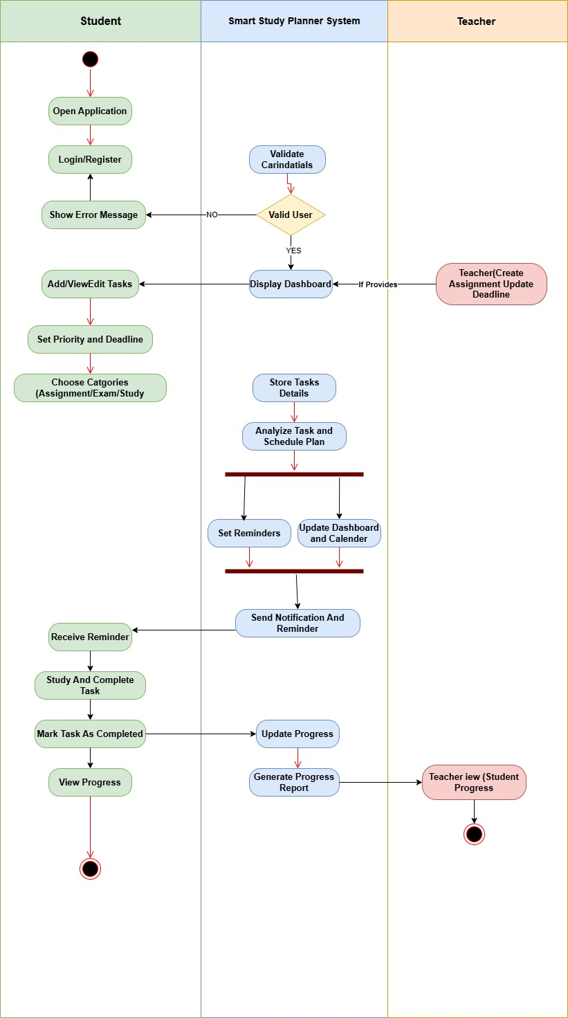
Figure 5

Key Elements of the Diagram
- Initial Node: Represents the start of the process
- Final Node: Represents the end of the process
- Activities: Actions performed by users or system
- Decision Node: Validates user credentials
- Swimlanes: Show responsibilities of Student, System, and Teacher
- Parallel Activities: Represent simultaneous process.

